**Step by step guide on how to install MetaMask Extension to your Browser and installing a test network.  
  
  
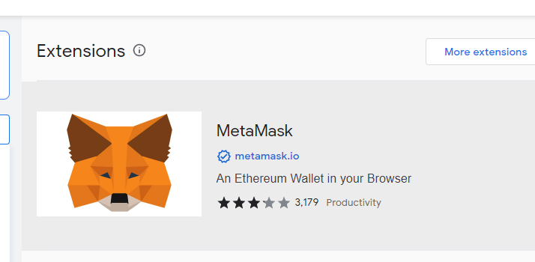**

**MetaMask is a software cryptocurrency wallet used to interact with the Ethereum blockchain. It allows users to access their Ethereum wallet through a browser extension or mobile app, which can then be used to interact with decentralized applications.**

**Step 1: Install MetaMask to your browser**

1 ) search for metamask extension   
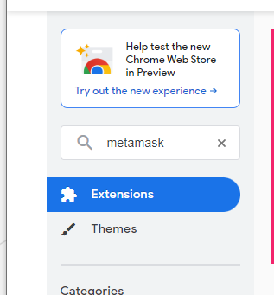

2.Click "Add Extension," and it will promptly download the file, seamlessly installing it into your Chrome browser.

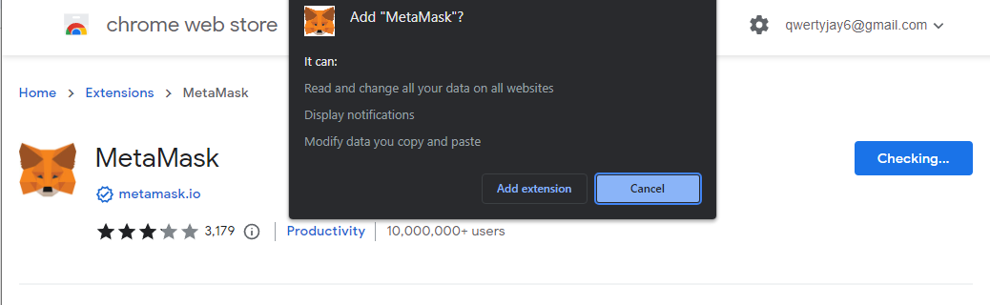

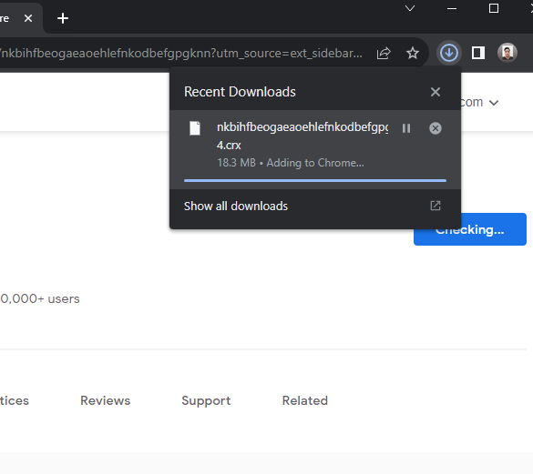

**Step 2: Create your MetaMask account**

1. Click “**Create a new Wallet”** button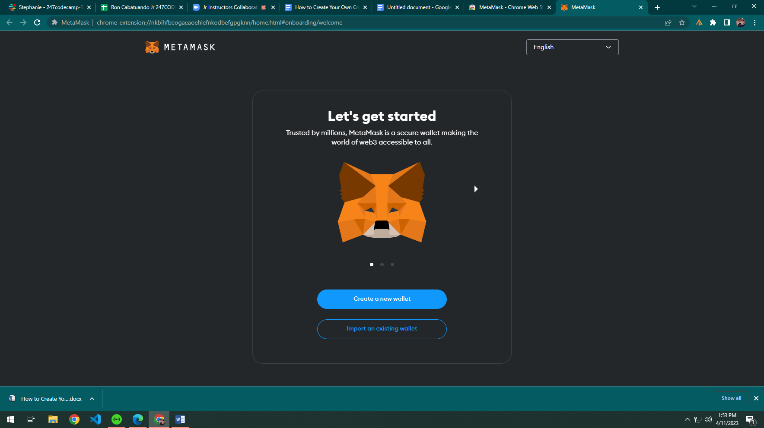

2. Read and accept the Terms of Use and Privacy Policy. Click “**Agree”**  
  
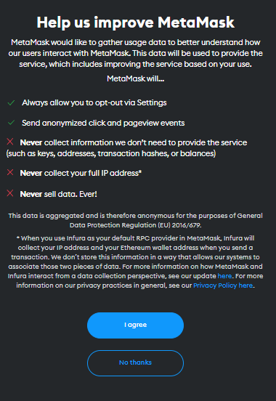  
3. Create a password and username   
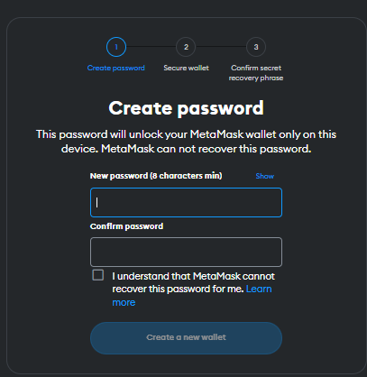

4.MetaMask will provide a 12- word recovery phrase. Write down and save it in a place that you can trust. Click “**Next”**.

5.Confirm your secret recover phrase. After that, you now have your own MetaMask wallet.

**3.Adding a smart chain test networks (ex. Mumbai test net)**

Visit the chainlist website <https://chainlist.org/> 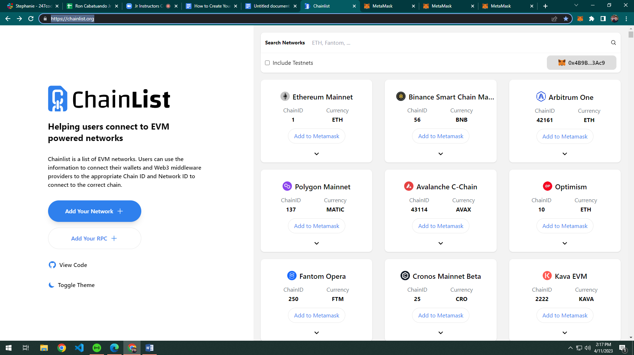

1. In the seach bar, type “**Sepolia**”. Click include testnets.

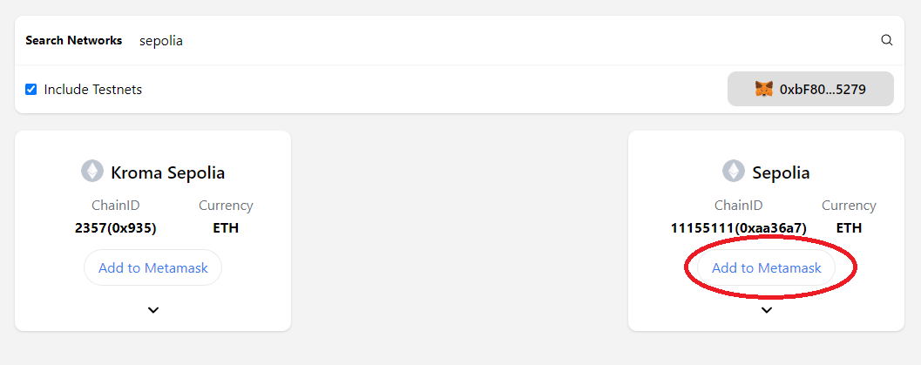

1. Click **“Add to MetaMask”** Button**.** A MetaMask prompt will appear, click “**Next**”.

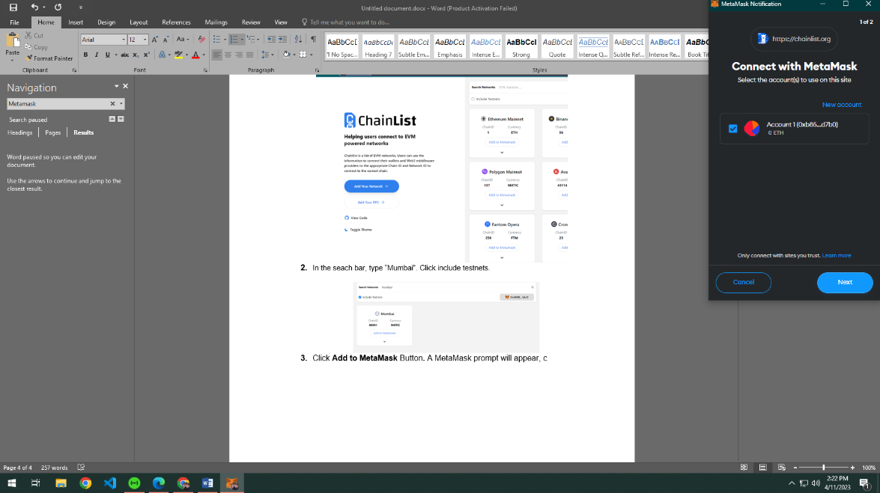

1. Click connect and approve Mumbai to be added to your network. You will be asked to allow this site to switch network. Click “**Switch Network”**.

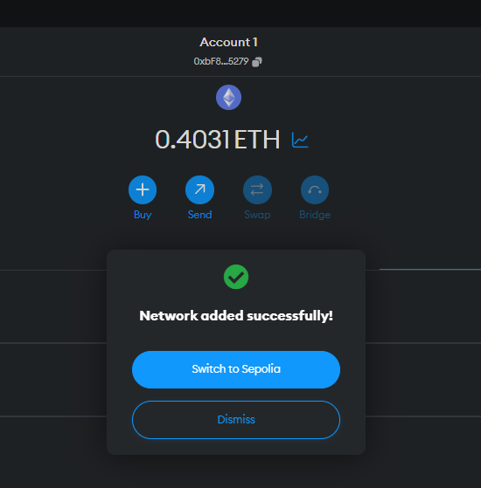

1. To get your test net Sepolia ETH token, click metamask in your browser extension and copy your Metamask public address on the center upper corner of your MetaMask.

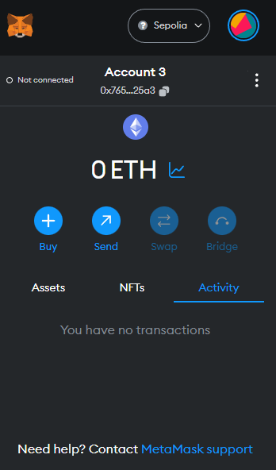

**5.Visit the website** <https://sepoliafaucet.com/> and paste your Metamask public address to the wallet address and click “**Send me ETH”**.

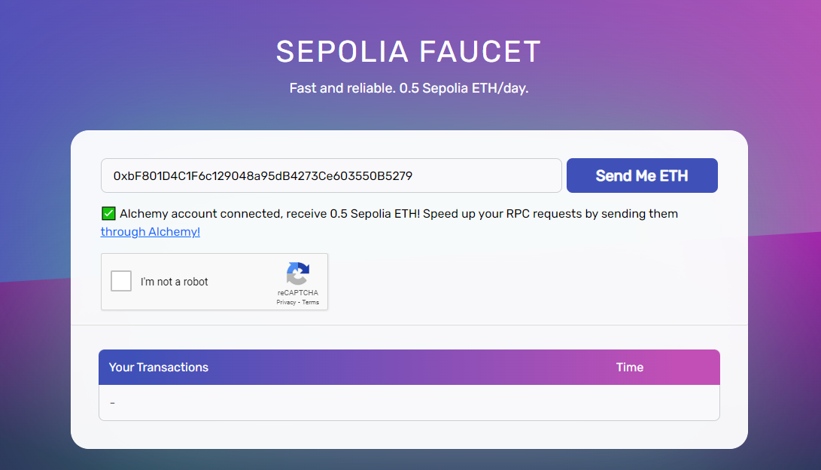

6.Sepolia ETH test token will then be added to your MetaMask. Congrats! You have successfully added the Sepolia Testnet network and added test token to your Metamask wallet.